COAL MINE SAFETY MONITORING SYSTEM

ABSTRACT
This project presents a safety monitoring system for coal mines using IoT technology. It uses a NodeMCU microcontroller connected to a temperature sensor and a gas sensor to detect hazardous conditions. The system displays real-time data on an LCD screen and activates a buzzer when dangerous levels are detected. The NodeMCU processes sensor readings and can be connected to cloud platforms for remote alerts and data logging. This compact and cost-effective system helps prevent accidents by providing early warnings and continuous monitoring in underground environments.

CHAPTER 1
EMBEDDED SYSTEMS

INTRODUCTION TO EMBEDDED SYSTEMS

Each day, our lives become more dependent on 'embedded systems', digital information technology that is embedded in our environment. More than 98% of processors applied today are in embedded systems, and are no longer visible to the customer as 'computers' in the ordinary sense. An Embedded System is a special-purpose system in which the computer is completely encapsulated by or dedicated to the device or system it controls. Unlike a general-purpose computer, such as a personal computer, an embedded system performs one or a few pre-defined tasks, usually with very specific requirements. Since the system is dedicated to specific tasks, design engineers can optimize it, reducing the size and cost of the product. Embedded systems are often mass- produced, benefiting from economies of scale.

The increasing use of PC hardware is one of the most important developments in high-end embedded systems in recent years. Hardware costs of high-end systems have dropped dramatically as a result of this trend, making feasible some projects which previously would not have been done because of the high cost of non-PC-based embedded hardware. But software choices for the embedded PC platform are not nearly as attractive as thehardware.

Typically, an embedded system is housed on a single microprocessor board with the programs stored in ROM. Virtually all appliances that have a digital interface -- watches, microwaves, VCRs, cars -- utilize embedded systems. Some embedded systems include an operating system, but many are so specialized that the entire logic can be implemented as a single program. Physically, Embedded Systems range from portable devices such as digital watches and MP3 players, to large stationary installations like traffic lights, factory controllers, or the systems controlling nuclear power plants. The applications software on such processors is sometimes referred to as firmware. The simplest devices consist of a single microprocessor (often called a "chip”), which may itself be packaged with other chips in a hybrid system or Application Specific Integrated Circuit (ASIC). Its input comes from a detector or sensor and its output goes to a switch or activator which (for example) may start or stop the operation of a machine or, by operating a valve, may control the flow of fuel to an engine. As the embedded system is the combination of both software and hardware.

DEFINITION OF AN EMBEDDED SYSTEM

Embedded system is defined as, for a particular/specific application implementing the software code to interact directly with that particular hardware what we built. Software is used for providing features and flexibility.

Hardware = {Processors, ASICs, Memory...} is used for Performance (& sometimes security).There are many definitions of embedded system but all of these can be combined into a single concept. An embedded system is a special purpose computer system that is used for particular task.

EXAMPLES OF AN EMBEDDEDSYSTEMS

Embedded systems are found in wide range of application areas. Originally they were used only for expensive industrial control applications, but as technology brought down the cost of dedicated processors, they began to appear in moderately expensive applications such as automobiles, communication and office equipments and television Today's embedded systems are so inexpensive that they are used in almost every electronic product in our life. Embedded systems are often designed for mass production.

    - Automatic TellerMachines
    - Cellular telephone and telephoneswitches
    - Computer networkequipment
    - Computerprinters
    - Diskdrives
    - Home automationproducts
    - Handheldcalculators
    - Householdappliances
    - Medicalequipment
    - Measurementequipment
    - Multifunction wristwatches
    - Multifunctionprinters

HISTORY OF AN EMBEDDEDSYSTEMS

The first recognizably modern embedded systems was the Apollo Guidance Computer, developed by “Charles Stark Draper” at the MIT Instrumentation Laboratory. At the project inception, the Apollo guidance computer was considered the riskiest item inthe Apollo project as it employed the then newly developed monolithic integrated circuits to reduce the size and weight. An early mass produced embedded system was the Autonetics D-17 guidance computer for the Minuteman missile, released in 1961.It was built from transistor logic and had a hard disk for main memory .When the Minuteman II went into production in 1966, the D-17 was replaced with a new computer that was the first high volume use of integrated circuits. This program alone reduced prices on quad and gate ICs from $1000/ each to $3/ each permitting their use in commercialproducts.

Since these early applications in the 1960s, embedded systems have come down in price and there has been a dramatic rise in processing power and functionality. The first microprocessor for example, the Intel 4004, was designed for calculators and other small systems but still required many external memory and support chips. In 1978 National Engineering Manufactures Association released a “standard” for programmable microcontrollers, including almost any computer based controllers, such as single board computers, numerical and event based controllers. Embedded Systems are designed to some specific task, rather than be a general-purpose computer for multitasks. Some also have real-time performances constraints that must be met, for reasons such as safety and usability; others may have low or no performance requirement, allowing the system hardware to be simplified to reducecost.
FEATURES OF AN EMBEDDEDSYSTEM

The versatility of the embedded computer system lends itself to utility in all kinds of enterprises, from the simplification of deliverable products to a reduction in costs in their development and manufacture. Complex systems with rich functionality employ special Operating systems that take into account major characteristics of embedded systems. Embedded operating systems have minimized footprint and may follow real-time operating system specifics.
The special computers system is usually less powerful than general-purpose systems, although some expectations do exist where embedded systems are very powerful and complicated. Usually a low power consumption CPU with a limited amount of memory is used in embedded systems. Many embedded systems use very small operating systems; most of these provide very limited operating system capabilities.
Since the embedded system is dedicated to specific tasks, design engineers can optimize it, reducing the size and cost of the product, or increasing the reliability and performance. Some embedded systems are mass-produced, benefiting from economies ofscale. Some embedded systems have to operate in extreme environment conditions such as very high temperature &humidity. For high volume systems such as portable music players or mobile phones,minimizingcost is usually the primary design consideration. Engineers typically select hardware that is just “good enough” to implement the necessary functions. For low volume or prototype embedded systems, general purpose computers may be adapted by limiting the programs or by replacing the operating system with a real-time operating system.

OVERVIEW OF AN EMBEDDED SYSTEM ARCHITECTURE

Every embedded system consists of custom-built hardware built around a Central Processing Unit (CPU). This hardware also contains memory chips onto which the software is loaded. The software residing on the memory chip is also called the ‘firmware’. The embedded system architecture can be represented as a layered architecture as shown in Fig.
The same architecture is applicable to any computer including a desktop computer. However, there are significant differences. It is not compulsory to have an operating system in every embedded system. For small appliances such as remote control units, air conditioners, toys etc., there is no need foran operating system and you can write only the software specific to thatapplication.

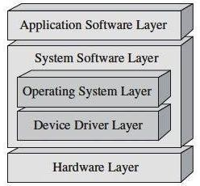

Fig 1.1 Layered Architecture of Embedded System
For applications involving complex processing, it is advisable to have an operating system. In such a case, you need to integrate the application software with the operating system and then transfer the entire software on to the memory chip. Once the software is transferred to the memory chip, the software will continue to run for a long time you don’t need to reload newsoftware.
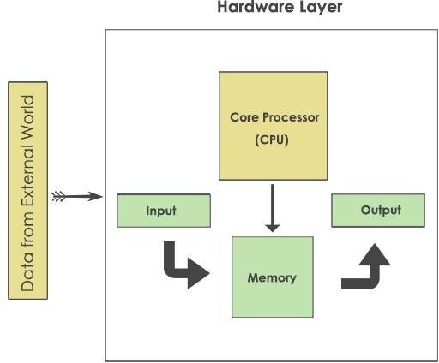

Fig 1.2 Block diagram of Embedded systems

Now, let us see the details of the various building blocks of the hardware of an embedded system. As shown in Fig. the building blocks are;
- Central Processing Unit(CPU)
- Memory (Read-only Memory and Random AccessMemory)
- InputDevices
- Outputdevices
- Communicationinterface
- Application-specific circuitry

Central Processing Unit (CPU)
The Central Processing Unit (processor, in short) can be any of the following: microcontroller,microprocessor or Digital Signal Processor (DSP). A micro-controller is a low-cost processor. Its main attraction is that on the chip itself, there will be manyother
components such as memory, serial communication interface, analog-to digital converter etc. So, for small applications, a micro-controller is the best choice as the number of external components required will be very less. On the other hand, microprocessors are more powerful, but you need to use many external components with them. D5P is used mainly for applications in which signal processing is involved such as audio and video processing.

Memory
The memory is categorized as Random Access 11emory (RAM) and Read Only Memory (ROM). The contents of the RAM will be erased if power is switched off to the chip, whereas ROM retains the contents even if the power is switched off. So, the firmware is stored in the ROM. When power is switched on, the processor reads the ROM; the program is program isexecuted.

Input devices
Unlike the desktops, the input devices to an embedded system have very limited capability. There will be no keyboard or a mouse, and hence interacting with the embedded system is no easy task. Many embedded systems will have a small keypad-you press one key to give a specific command. A keypad may be used to input only the digits. Many embedded systems used in process control do not have any input device for user interaction; they take inputs from sensors or transducers 1’fnd produce electrical signals that are in turn fed to other systems.

Output devices
The output devices of the embedded systems also have very limited capability. Some embedded systems will have a few Light Emitting Diodes (LEDs) to indicate the health status of the system modules, or for visual indication of alarms. A small Liquid Crystal Display (LCD) may also be used to display some important parameters.

Communication interfaces
The embedded systems may need to, interact with other embedded systems at they may have to transmit data to a desktop. To facilitate this, the embedded systems are provided with one or a few communication interfaces such as RS232, RS422, RS485, Universal Serial Bus (USB), IEEE 1394, Ethernetetc.

Application-specific circuitry
Sensors, transducers, special processing and control circuitry may be required fat an embedded system, depending on its application. This circuitry interacts with the processor to carry out the necessary work. The entire hardware has to be given power supply either through the 230 volts main supply or through a battery. The hardware has to design in such a way that the power consumption is minimized.

CHAPTER 2
PROPOSED SYSTEM

INTRODUCTION
Coal mining is one of the most hazardous industries due to the presence of toxic gases, high temperatures, and the risk of explosions or cave-ins. Traditional safety measures often rely on manual inspections, which can be slow and prone to human error. To improve worker safety and reduce accidents, modern technologies such as the Internet of Things (IoT) are being integrated into mining operations.
This project introduces an IoT-based coal mine safety monitoring system that continuously tracks environmental conditions underground. Using a NodeMCU microcontroller connected to temperature and gas sensors, the system detects hazardous conditions in real time. Data is displayed on an LCD screen for local monitoring, while a buzzer provides immediate alerts during dangerous situations. Additionally, IoT connectivity allows data to be transmitted to cloud platforms for remote monitoring and logging, enabling supervisors to take timely action. This compact, cost-effective solution enhances safety standards and ensures continuous monitoring in coal mines.

LITERATURE SURVEY

"IoT Based Coal Mine Safety Monitoring System"
P. K. Sahu, A. K. Sahoo
This paper presents an IoT-based system for monitoring coal mine safety using temperature and gas sensors. The NodeMCU microcontroller processes sensor data and provides real-time alerts through LCD and buzzer. The authors emphasize affordability and portability, making the system suitable for underground environments. They discuss challenges such as sensor calibration and propose solutions for accuracy. The study concludes that IoT-based monitoring enhances worker safety and reduces accident risks.

"Gas and Temperature Monitoring in Underground Mines Using IoT"
J. Y. Lee, S. H. Kim
This research explores IoT-based monitoring systems for underground mines, focusing on gas and temperature detection. The authors describe how sensors integrated with microcontrollers can transmit data to cloud platforms for remote monitoring. The paper discusses system architecture, threshold detection, and integration with mine management systems. Challenges such as false alarms and sensor placement are addressed. The study concludes that IoT-based monitoring improves mine safety and operational efficiency.

"IoT Applications in Industrial Safety: A Review"
Sajjad Hussain, Khizer Saeed
This review surveys IoT applications in industrial safety, including mining, oil, and chemical industries. The authors analyze existing systems and highlight their strengths and limitations. They emphasize the role of IoT in providing real-time communication and adaptive monitoring. The paper also discusses challenges such as affordability, scalability, and data privacy. The authors conclude that IoT has the potential to revolutionize industrial safety by offering intelligent, reliable, and cost-effective solutions.

"Smart Mine Safety System Using IoT and Cloud Integration"
Vinay Meshram, Pranit Bonde
This study introduces a smart mine safety system that integrates IoT devices with cloud platforms. The system uses sensors to detect hazardous gases and temperature changes, with NodeMCU processing data and transmitting it to the cloud. Supervisors can access real-time alerts via mobile apps. The authors highlight the importance of cloud integration for storing safety logs and enabling advanced analytics. They also discuss future enhancements such as AI-based anomaly detection. The paper concludes that IoT and cloud integration significantly improve mine safety and monitoring.

"Multisensor Integration and Fusion in Intelligent Systems"
R. C. Luo, M. G. Kay
This paper focuses on multisensor integration and fusion techniques in intelligent systems, relevant to IoT-based mine safety projects. The authors explain how combining data from multiple sensors improves accuracy and reliability. They discuss algorithms for sensor fusion and highlight applications in industrial safety monitoring. The study emphasizes the importance of integrating temperature sensors, gas sensors, and IoT platforms to enhance functionality. The authors conclude that sensor fusion is critical for building robust and intelligent mine safety systems.

EXISTING SYSTEM
Traditional coal mine safety systems rely on manual inspections and basic alarm setups. These methods are slow and often fail to detect sudden changes in temperature or gas concentration. Many mines lack real-time monitoring tools, making it difficult to respond quickly to emergencies. Conventional systems are not integrated with IoT platforms, so remote alerts and data tracking are unavailable. This leads to delayed evacuation, increased risk of accidents, and limited visibility for safety teams.

PROPOSED SYSTEM
The proposed system uses sensors to continuously monitor temperature and gas levels in coal mines. The NodeMCU microcontroller collects and processes this data. If dangerous conditions are detected, the buzzer sounds an alert and the LCD displays the current readings. The system can be connected to IoT platforms for remote monitoring and notifications. It is easy to install, energy-efficient, and suitable for harsh underground environments. By providing real-time feedback and early warnings, the system improves worker safety and supports faster emergency response.

BLOCK DIAGRAM
Node MCU
Micro Controller
Temperature Sensor
LCD Display
Buzzer
Gas Sensor

WORKING
- Sensors
  - Temperature sensor monitors underground heat levels.
  - Gas sensor detects hazardous gases such as methane or carbon monoxide.
- Data Processing
  - NodeMCU microcontroller collects sensor readings.
  - Threshold values are set to identify dangerous conditions.
- Alerts and Display
  - LCD screen shows real-time sensor data.
  - Buzzer activates when unsafe levels are detected.
- IoT Connectivity
  - NodeMCU transmits data to cloud platforms via Wi-Fi.
  - Remote alerts and logs are accessible to supervisors for continuous monitoring.

ADVANTAGES
- Early Warning System: Provides immediate alerts to prevent accidents.
- Continuous Monitoring: Tracks environmental conditions in real time.
- Remote Access: IoT connectivity enables supervisors to monitor conditions from anywhere.
- Cost-Effective: Uses affordable components like NodeMCU and sensors.
- Compact Design: Portable and easy to install in underground environments.
- Improved Safety: Reduces risks of explosions and toxic exposure.
- Data Logging: Maintains records for analysis and preventive measures.

APPLICATIONS
- Underground coal mine safety
- Hazard detection in tunnels and shafts
- Remote monitoring for mining operations
- Worker health protection in confined spaces
- Industrial safety in gas-prone environments

CHAPTER 3
HARDWARE REQUIREMENTS

Node MCU
Technically speaking NodeMCU is a firmware for ESP8266 developed using C Programming Language, Espressif NON-OS SDK and Lua scripting language. Traditionally, we write code for our Microcontrollers like Arduino, STM32, 8051 etc., either in C or C++ and compile it with a set of tools and generate a binary file. This binary file is then uploaded into the flash memory of the microcontroller and it gets executed. Things are quite different with NodeMCU. You can consider the NodeMCU firmware as an interpreter for Lua Scripts. So, if your ESP8266 is loaded with NodeMCU Firmware, you can simply write your application in Lua and send it to the ESP8266.NodeMCU Firmware will interpret the byte code and executes the commands. There is no compilation, no binary file etc. Just write a script and run it the team which developed NodeMCU Firmware also developed a breakout board for ESP-12E module called the NodeMCU Devkit. So, many of us are actually using the board called NodeMCU and programming it with Arduino IDE and not the Lua Scripts.
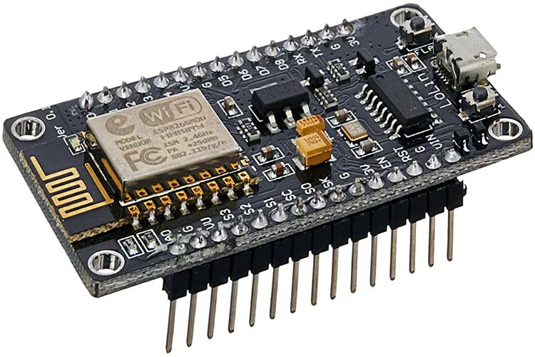
IMPORTANT NOTE: Only one firmware can exist on the ESP8266. It can be either AT Commands Firmware, NodeMCU Firmware or Arduino based code. Once you upload an Arduino sketch, the NodeMCU firmware gets erased. If you want to work with Lua Scripts and NodeMCU, then you have to flash the NodeMCU Firmware.
ESP-01 vs. NodeMCU (ESP-12E)
As mentioned earlier, the NodeMCU Devkit is actually a Breakout Board for the ESP-12E Module. The ESP-01 is the vanilla version of the ESP8266 Wi-Fi SoC made by Ai–Thinker, a third part module manufacturer for ESP8266.

Brief about NodeMCU ESP8266
The NodeMCU ESP8266 development board comes with the ESP-12E module containing the ESP8266 chip having Tensilica Xtensa 32-bit LX106 RISC microprocessor. This microprocessor supports RTOS and operates at 80MHz to 160 MHz adjustable clock frequency. NodeMCU has 128 KB RAM and 4MB of Flash memory to store data and programs. Its high processing power with in-built Wi-Fi / Bluetooth and Deep Sleep Operating features make it ideal for IoT projects.
NodeMCU can be powered using a Micro USB jack and VIN pin (External Supply Pin). It supports UART, SPI, and I2C interface.
- ESP8266 Chip: The core of the NodeMCU module is the ESP8266 chip, which provides Wi-Fi connectivity and microcontroller functionality.

- GPIO Pins: The NodeMCU board includes multiple digital and analog pins that can be used to connect various peripherals such as sensors, LEDs, and motors.

- Serial Communication Protocols: It supports UART, SPI, and I2C protocols, enabling communication with other devices and modules.

- Open-Source Firmware: The NodeMCU firmware is open-source and based on the Lua scripting language, making it easy to program and customize.
•Compact Design: The NodeMCU module is small and lightweight, making it suitable for various applications, from hobby projects to professional IoT solutions

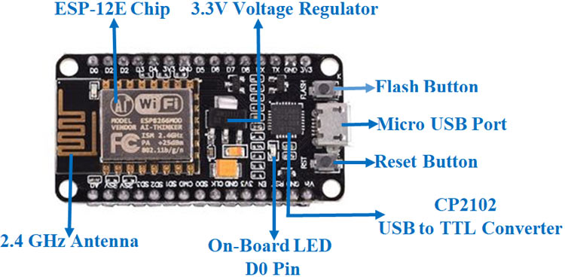

ESP8266 Wi-Fi module
ESP8266 comes up with powerful processing speed on board. Storage space of this module is also high allowing it to integrate with other devices like sensors. To make this module compatible with other development boards, we have to do level shifting of voltages externally because this board doesn’t come up with on-board voltage regulator. This module is cost effective and thus used widely in many applications like the Internet of things and much more. So in this article, we are going to discuss key features of ESP8266, pins specifications, how to use this board for programming purposes and a sample program.
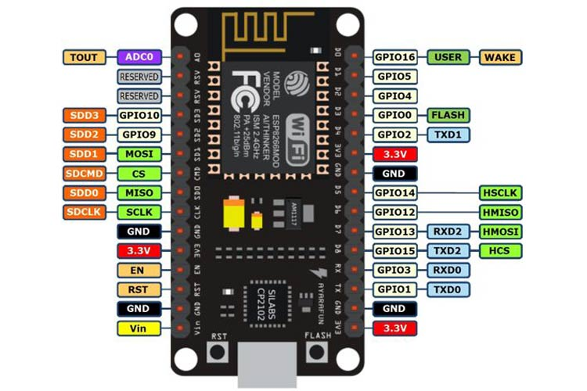

NodeMCU ESP8266 Specifications & Features
The Node MCU module is built around the powerful ESP8266 microcontroller, which is well-suited for IoT applications due to its integrated Wi-Fi capabilities and robust processing power. Here’s a detailed look at its specifications:
Microcontroller: Tensilica 32-bit RISC CPU Xtensa LX106
The core of the NodeMCU is the Tensilica Xtensa LX106, a 32-bit RISC CPU known for its efficiency and performance in handling complex tasks with low power consumption.
Operating Voltage: 3.3V
The module operates at a standard 3.3V, making it compatible with a wide range of sensors and peripherals that also use 3.3V logic levels.
Input Voltage: 7-12V
It accepts an input voltage range of 7-12V, which is regulated down to 3.3V by the onboard regulator, ensuring stable operation and protecting the microcontroller from voltage fluctuations.
Digital I/O Pins (DIO): 16
The NodeMCU provides 16 digital input/output pins that can be used to interface with various sensors, actuators, and other digital devices. These pins can be programmed for general purpose use, such as reading sensor data or controlling LEDs.
Analog Input Pin (ADC): 1
There is one analog input pin available, allowing for the connection of analog sensors. This pin can read voltage levels and convert them into digital values for processing.
UARTs: 1
The module includes one UART (Universal Asynchronous Receiver/Transmitter) for serial communication, which is essential for debugging and connecting to other serial devices.
SPIs: 1
One SPI (Serial Peripheral Interface) is available, providing high-speed communication with devices like SD cards, displays, and other SPI peripherals.
I2Cs: 1
The I2C (Inter-Integrated Circuit) bus allows for communication with multiple I2C devices using only two wires, making it ideal for connecting sensors and modules that support I2C communication.
Flash Memory: 4 MB
The NodeMCU is equipped with 4 MB of flash memory for storing the firmware and user programs. This ample storage space allows for the development of complex applications and features.
SRAM: 64 KB
It includes 64 KB of SRAM (Static Random Access Memory) for data storage and processing during runtime. This memory is used for variables, data buffers, and program execution.
Clock Speed: 80 MHz
The microcontroller operates at a clock speed of 80 MHz, providing sufficient processing power for handling various tasks efficiently and in real-time.
USB-TTL based on CP2102:
The onboard CP2102 USB-to-TTL converter allows for easy programming and serial communication over USB. It enables plug-and-play functionality, simplifying the setup and development process.
PCB Antenna:
The NodeMCU features an integrated PCB antenna, which provides reliable Wi-Fi connectivity without the need for an external antenna. This design keeps the module compact and easy to use.
Compact Size:
The small form factor of the NodeMCU module makes it ideal for integration into IoT projects, where space is often limited. Its compact size allows it to fit seamlessly into a wide range of applications, from home automation to wearable devices.

Installation Steps
Now, to install the NODE MCU board in the Arduino IDE, you need to follow the below steps −
- Make sure you have Arduino IDE (preferably the latest version) installed on your machine
- Open Arduino and go to File −> Preferences
- In the Additional Boards Manager URL, enter
https://dl.espressif.com/dl/package_ESP8266_index.json
In case you have an existing JSON file's URL in the preferences (this is likely if you've installed ESP8266, stm32duino, or any such additional board in the IDE), you can just append the above path to the existing path, using a comma. An example is shown below, for ESP8266 and NODE MCU boards −
http://arduino.esp8266.com/stable/package_esp8266com_index.json, https://dl.espressif.com/dl/package_ESP8266_index.json
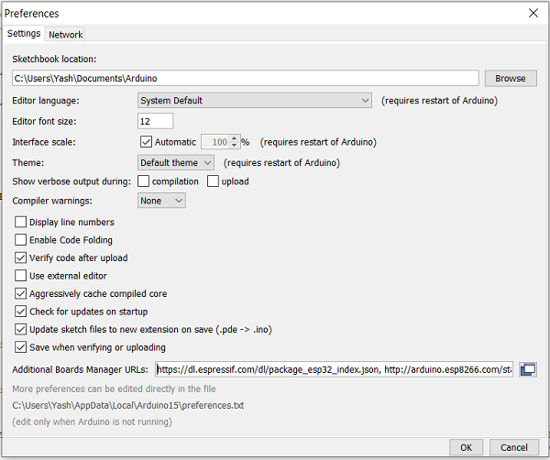
Go to Tools −> Board−> Boards Manager. A pop−up would open up. Search for ESP8266and install the ESP8266by Espressif Systems board. The image below shows the board already installed because I had installed the board before preparing this tutorial.
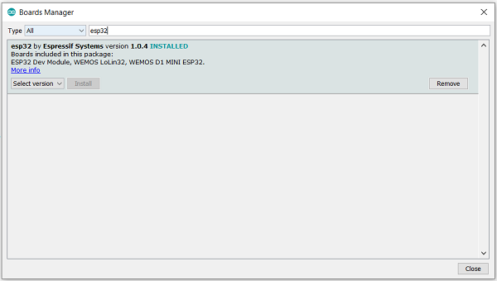

Verifying the Installation
Once your ESP8266board has been installed, you can verify the installation by going to Tools −> Boards. You can see a whole bunch of boards under the ESP8266Arduino section. Choose the board of your choice. If you are not sure which board best represents the one you have, you can choose ESP8266Module.
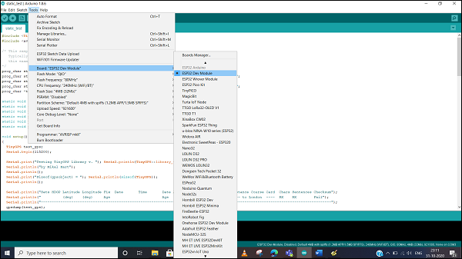
Next, connect your board to your machine using the USB Cable. You should see an additional COM Port under Tools−> Port. Select that additional port. In case you see multiple ports, you can disconnect the USB and see which port disappeared. That port corresponds to ESP8266.
Once the port is identified, pick any one example sketch from File −> Examples. We will choose the Start Counter example from File −> Examples −> Preferences −> Start Counter.
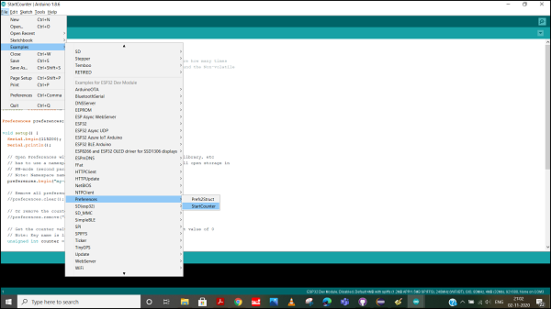
Open that sketch, compile it and flash it into the ESP8266by clicking on the Upload button (the right arrow button, besides the Compile button).
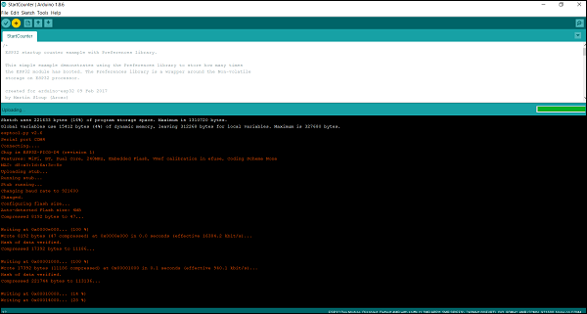
Then open the Serial Monitor using Tools −> Serial Monitor, or simply by pressing Ctrl + Shift + M on your keyboard. You should see the counter value getting incremented after every ESP8266restart.
TEMPERATURE SENSOR
A temperature sensor is a device, typically, a thermocouple or resistance temperature detector, that provides temperature measurement in a readable form through an electrical signal.A thermometer is the most basic form of a temperature meter that is used to measure the degree of hotness and coolness.
Temperature meters are used in the geotechnical field to monitor concrete, structures, soil, water, bridges, etc. for structural changes in due to seasonal variations. A thermocouple (T/C) is made from two dissimilar metals that generate an electrical voltage in direct proportion to the change in temperature. An RTD (Resistance Temperature Detector) is a variable resistor that changes its electrical resistance in direct proportion to the change in the temperature in a precise, repeatable, and nearly linear manner.
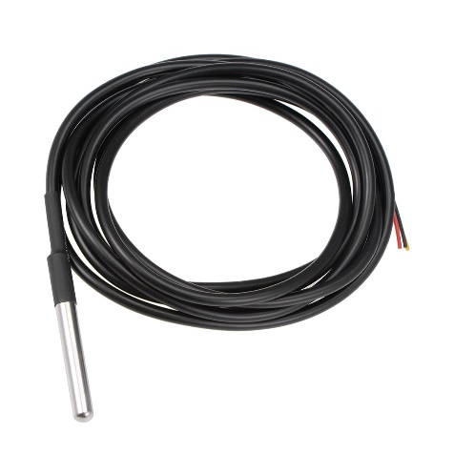
Temperature sensor
A temperature sensor is a device that is designed to measure the degree of hotness or coolness in an object. The working of a temperature meter depends upon the voltage across the diode. The temperature change is directly proportional to the diode’s resistance. The cooler the temperature, the lesser will be the resistance, and vice-versa. The resistance across the diode is measured and converted into readable units of temperature (Fahrenheit, Celsius, Centigrade, etc.) and, displayed in numeric form over readout units. In the geotechnical monitoring field, these temperature sensors are used to measure the internal temperature of structures like bridges, dams, buildings, power plants, etc.
The basic principle of working the temperature sensors is the voltage across the diode terminals. If the voltage increases, the temperature also rises, followed by a voltage drop between the transistor terminals of the base and emitter in a diode. Besides this, Encardio Rite has a vibrating wire temperature sensor that works on the principle of stress change due to temperature change. The vibrating wire temperature meter is designed on the principle that dissimilar metals have a different linear coefficient of expansion with temperature variation.
It primarily consists of a magnetic, high tensile strength stretched wire, the two ends of which are fixed to any dissimilar metal in a manner that any change in temperature directly affects the tension in the wire and, thus, its natural frequency of vibration. The dissimilar metal, in the case of the Encardio Rite temperature meter, is aluminium (Aluminium has a larger coefficient of thermal expansion than steel.) As the temperature signal is converted into frequency, the same read-out unit which is used for other vibrating wire sensors can also be used for monitoring temperature also.
DS18B20 Pin Configuration:
The DS18B20 temperature sensor pin configuration is shown below. So this sensor includes three pins which are explained below.
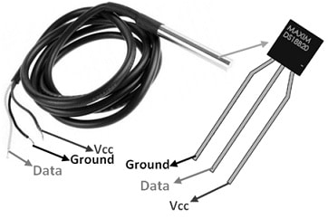
DS18B20 Pin Configuration
Pin-1 (GND): This is the Ground pin of the temperature sensor, so connected to the microcontroller’s GND terminal.
Pin-2 (VCC): This is the power supply pin of the temperature sensor so connected to the 3.3V/5V terminal of the microprocessor or microcontroller.
Pin-3 (DATA): This is the o/p pin of the temperature sensor that provides the output with one wire method. So it must be attached to a digital pin on the microprocessor or microcontroller.

Features & Specifications:
The features and specifications of the DS18B20 temperature sensor include the following.
- DS18B20 is a digital temperature sensor.
- This sensor is available in different packages like 8-Pin SO, 8-Pin µSOP & 3-Pin TO-92.
- Its unique 64-bit address allows multiplexing.
- It doesn’t need external components.
- This sensor needs two pins only for operation in parasitic power mode.
- Several temperature sensors can share a single pin of microprocessor/microcontroller.
- It includes programmable alarm options.
- Its unique single-wire interface needs a single digital pin of microprocessor or microcontroller only for its communication.
- Its accuracy is ±0.5°C
- This sensor’s resolution is 9- bits, 10- bits, 11- bits, (or) 12-bits.
- Its operating voltage ranges from 3V to 5.5V.
- DS18B20 sensor includes an alarm feature with low and high user-settable temperature thresholds
- These sensors are waterproof, so used in moisture-exposed environments.
- It communicates through a 1-Wire bus that requires only one data line used for communication.
- Each DS18B20 sensor has a unique 64-bit serial code that allows several DS18B20 sensors to work on a similar 1-Wire bus.
GAS SENSOR
A gas sensor is a device which detects the presence or concentration of gases in the atmosphere. Based on the concentration of the gas the sensor produces a corresponding potential difference by changing the resistance of the material inside the sensor, which can be measured as output voltage. Based on this voltage value the type and concentration of the gas can be estimated.
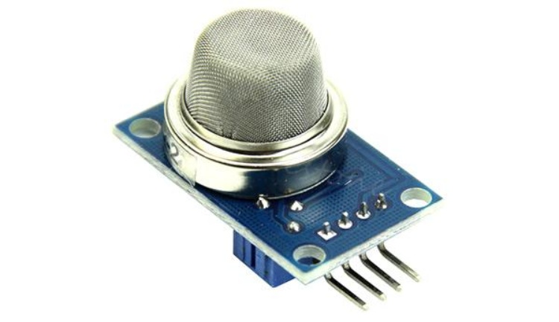

The type of gas the sensor can detect depends on the sensing material present inside the sensor. Normally these sensors are available as modules with comparators as shown above. These comparators can be set for a particular threshold value of gas concentration. When the concentration of the gas exceeds this threshold the digital pin goes high. The analog pin can be used to measure the concentration of the gas.
The below image illustrates the parts present in a metal oxide gas sensor

And here is an actual such senor with its protective cover removed.
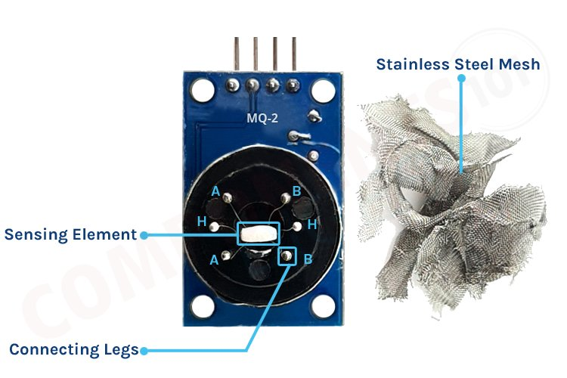
The purpose of each of these elements is as below:
Gas sensing layer: It is the main component in the sensor which can be used to sense the variation in the concentration of the gases and generate the change in electrical resistance. The gas sensing layer is basically a chemiresistor which changes its resistance value based on the concentration of a particular gas in the environment. Here the sensing element is made up of a Tin Dioxide (SnO2) which, in general, has excess electrons (donor element). So whenever toxic gases are being detected the resistance of the element changes and the current flown through it varies which represents the change in concentration of the gases.
Heater coil: The purpose of the heater coil is to burn in the sensing element so that the sensitivity and efficiency of the sensing element increase. It is made of Nickel-Chromium which has a high melting point so that it can stay heated up without getting melted.
Electrode line: As the sensing element produces a very small current when the gas is detected it is more important to maintain the efficiency of carrying those small currents. So, Platinum wires come into play which helps in moving the electrons efficiently.
Electrode: It is a junction where the output of the sensing layer is connected to the Electrode line. So that the output current can flow to the required terminal. An electrode here is made of Gold (Au –Aurum) which is a very good conductor.
Tubular ceramic: In between the Heater coil and Gas sensing layer, the tubular ceramic exists which is made of Aluminum oxide (Al2O3). As it has a high melting point, it helps in maintaining the burn-in (preheating) of the sensing layer which gives the high sensitivity for the sensing layer to get efficient output current.
Mesh over the sensing element: In order to protect the sensing elements and the setup, a metal mesh is used over it, which is also used to avoid/hold the dust particles entering into the mesh and prevent damaging the gas sensing layer from corrosive particles.
Gas Sensor Working
The ability of a Gas sensor to detect gases depends on the chemiresister to conduct current. The most commonly used chemiresistor is Tin Dioxide (SnO2) which is an n-type semiconductor that has free electrons (also called a donor). Normally the atmosphere will contain more oxygen than combustible gases. The oxygen particles attract the free electrons present in SnO2 which pushes them to the surface of the SnO2. As there are no free electrons available output current will be zero. The below gif shows the oxygen molecules (blue color) attracting the free electrons (black color) inside the SnO2 and preventing it from having free electrons to conduct current.
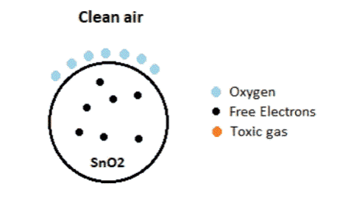
When the sensor is placed in a toxic or combustible gas environment, the reducing gas (orange color) reacts with the adsorbed oxygen particles and breaks the chemical bond between oxygen and free electrons thus releasing the free electrons. As the free electrons are back to their initial position, they can now conduct current, this conduction will be proportional to the number of free electrons available in SnO2, if the gas is highly toxic more free electrons will be available.
How to use a Gas sensor?
A basic gas sensor has 6 terminals of which 4 terminals (A, A, B, B) act as input or output and the remaining 2 terminals (H, H) are for heating the coil. Of these 4 terminals, 2 terminals from each side can be used as either input or output (these terminals are reversible as shown in the circuit diagram) and vice versa.
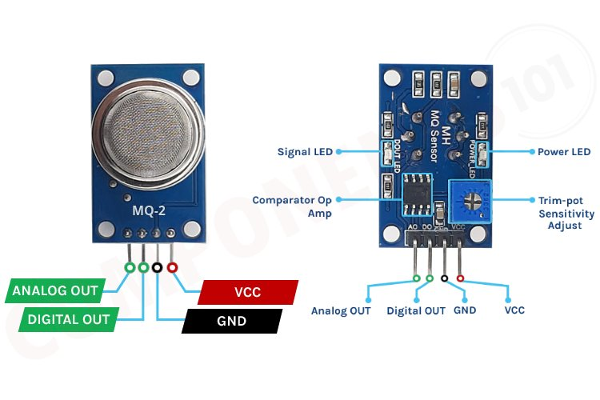
These sensors are normally available as modules (shown right), these modules consist of the gas sensor and a comparator IC. Now let’s see the pin description of the gas sensor module which we will generally use with an Arduino. The gas sensor module basically consists of 4 terminals
Vcc – Power supply
GND – Power supply
Digital output – This pin gives an output either in logical high or logical low (0 or 1) that means it displays the presence of any toxic or combustible gases near the sensor.
Analog output – This pin gives an output continuous in voltage which varies based on the concentration of gas that is applied to the gas sensor.
As discussed earlier the output of a gas sensor alone will be very small (in mV) so an external circuit has to be used in order to get a digital high-low output from the sensor. For this purpose, a comparator (LM393), an adjustable potentiometer, and some resistors and capacitors are used.
The purpose of LM393 is to get the output from the sensor, compare it with a reference voltage and display whether the output is logically high or not. Whereas the purpose of the potentiometer is to set the required threshold value of the gas above which the digital output pin should go high.
Most Popular Gas Sensors
Some of the most popular semiconductor gas sensors includes MQ-2, MQ-3, MQ-4, MQ-5, MQ-6, MQ-7, MQ-8, MQ-9, MQ-131, MQ-135, MQ-136, MQ-137, MQ-138, MQ-214, MQ-303A, MQ-306A and MQ-309A. Here are the most important specifications of these sensors.
Features
- Operating Voltage is +5V
- Can be used to Measure or detect LPG, Alcohol, Propane, Hydrogen, CO and even methane
- Analog output voltage: 0V to 5V
- Digital Output Voltage: 0V or 5V (TTL Logic)
- Preheat duration 20 seconds
- Can be used as a Digital or analog sensor
- The Sensitivity of Digital pin can be varied using the potentiometer
LCD
LCD is a flat display technology, stands for "Liquid Crystal Display," which is generally used in computer monitors, instrument panels, cell phones, digital cameras, TVs, laptops, tablets, and calculators. It is a thin display device that offers support for large resolutions and better picture quality. The older CRT display technology has replaced by LCDs, and new display technologies like OLEDs have started to replace LCDs. An LCD display is most commonly found with Dell laptop computers and is available as an active-matrix, passive-matrix, or dual-scan display. The picture is an example of an LCD computer monitor.
The Liquid Crystal library allows you to control LCD displays that are compatible with the Hitachi HD44780 driver. There are many of them out there, and you can usually tell them by the 16-pin interface.
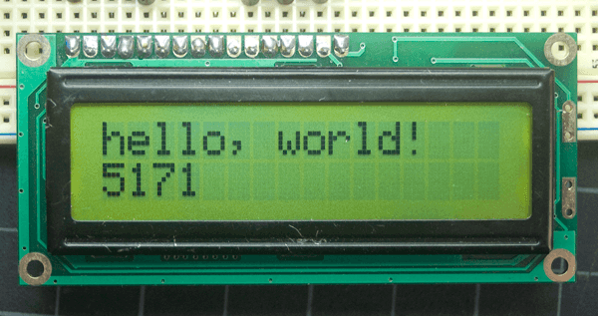
Output of the sketch on a 16x2 LCD
The LCDs have a parallel interface, meaning that the microcontroller has to manipulate several interface pins at once to control the display. The interface consists of the following pins:
- A register select (RS) pin that controls where in the LCD's memory you're writing data to. You can select either the data register, which holds what goes on the screen, or an instruction register, which is where the LCD's controller looks for instructions on what to do next.
- A Read/Write (R/W) pin that selects reading mode or writing mode
- An Enable pin that enables writing to the registers
- 8 data pins (D0 -D7). The states of these pins (high or low) are the bits that you're writing to a register when you write, or the values you're reading when you read.
There's also a display contrast pin (Vo), power supply pins (+5V and GND) and LED Backlight (Bklt+ and BKlt-) pins that you can use to power the LCD, control the display contrast, and turn on and off the LED backlight, respectively.
The process of controlling the display involves putting the data that form the image of what you want to display into the data registers, then putting instructions in the instruction register. The Liquid Crystal Library simplifies this for you so you don't need to know the low-level instructions.
The Hitachi-compatible LCDs can be controlled in two modes: 4-bit or 8-bit. The 4-bit mode requires seven I/O pins from the Arduino, while the 8-bit mode requires 11 pins. For displaying text on the screen, you can do most everything in 4-bit mode, so example shows how to control a 16x2 LCD in 4-bit mode.

LCD Pin Description:
The LCD requires 3 control lines (RS, R/W, and EN) and 8(or 4) data lines. The number of data lines depends on the mode of operation. If operated in 8-bit mode then 8-bit data lines are required. And if the operation is in 4-bit mode then 4-bit data lines are required. The 8-bit mode is faster than the 4-bit mode. In 8-bit mode, LCD uses a total of 14 pins including 8 data lines, 3 control lines, and 3 power supply lines (Vee Vss and Vee)
- Power Supply: The LCD discussed here uses three power supply pins (Vcc, Vss, and Vee) Vcc and Vss pins are used to provide +5V and ground respectively. The pin Vee is used for controlling LCD contrast.
- Control Lines: There are three control lines in the LCD. These three are used to control the LCD operations there are two very important registers inside the LCD: the command register and the data register. The RS (Register select) pin is used to select the register out of these two. If RS = 0 the command register is selected and the user is allowed to send the command to the LCD. If RS = 1, the data register is selected and the data sent by the user is displayed on the LCD.
R / W (Read/ Write) pin allows the user to read/write the information (data or code) to/ from the LCD. R /W = 1 when reading and R/W=0 when the writing operation is performed.
Another control pin EN (Enable) is used to latch the data present on the data pins. A high-low signal is required to latch the data. The LCD interprets and executes the commands at the instant the EN line is brought low.
- Data lines: The 8-bits data pins. D (0)-D (7) are used to send the information to the LCD or read the contents of the LCD’s internal register.

LCD Interfacing:

The LCD can be interfaced to the microprocessor 8085 using the programmable peripheral interface (PPI-8255) IC. To display letters and numbers. ASCII code for the letters A to Z, a to 7, and numbers 0 to 9 is sent to the data lines (D0 -D7). These codes may be sent to LCD data lines through one port of 8255 (PPI), port A is used as the output port and send the data to the LCD. The EN pin and RS pin are connected to port B of the 8255. Since it is used as a normal display R/W is made low by connecting to the ground directly. Power supply connections are provided to Vcc and Vss pins. The Vee pin is connected to the EE moving node of the potentiometer which is connected between the Vcc and Vss pins. By moving the potentiometer the contrast of the LCD can be changed.
BUZZER
An audio signalling device like a beeper or buzzer may be electromechanical or piezoelectric or mechanical type. The main function of this is to convert the signal from audio to sound. Generally, it is powered through DC voltage and used in timers, alarm devices, printers, alarms, computers, etc. Based on the various designs, it can generate different sounds like alarm, music, bell & siren.
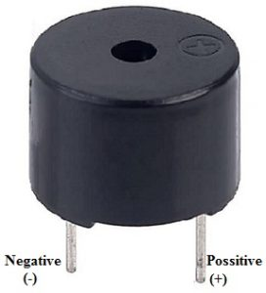
Buzzer Pin Configuration
The pin configuration of the buzzer is shown below. It includes two pins namely positive and negative. The positive terminal of this is represented with the ‘+’ symbol or a longer terminal. This terminal is powered through 6Volts whereas the negative terminal is represented with the ‘-‘symbol or short terminal and it is connected to the GND terminal.

CHAPTER 4

SOFTWARE CONSTRAINTS

INTRODUCTION TO ARDUINO IDE

Arduino is a prototype platform (open-source) based on an easy-to-use hardware and software. It consists of a circuit board, which can be programmed (referred to as a microcontroller) and a ready-made software called Arduino IDE (Integrated Development Environment), which is used to write and upload the computer code to the physical board.

KEY FEATURES OF ARDUINOIDE
Arduino boards are able to read analog or digital input signals from different sensors and turn it into an output such as activating a motor, turning LED on/off, connect to the cloud and many other actions.
You can control your board functions by sending a set of instructions to the microcontroller on the board via Arduino IDE (referred to as uploading software).
Unlike most previous programmable circuit boards, Arduino does not need an extra piece of hardware (called a programmer) in order to load a new code onto the board. You can simply use a USBcable.
Additionally, the Arduino IDE uses a simplified version of C++, making it easier to learn to program.Finally, Arduino provides a standard form factor that breaks the functions of the micro-controller into a more accessible package.
After learning about the main parts of the Arduino UNO board, we are ready to learn how to set up the Arduino IDE. Once we learn this, we will be ready to upload our program onthe Arduino board.

ARDUINO DATATYPES
Data types in C refers to an extensive system used for declaring variables or functions of different types. The type of a variable determines how much space it occupies in the storage and how the bit pattern stored isinterpreted.
The following table provides all the data types that you will use During Arduino programming.

Void
The void keyword is used only in function declarations. It indicates that the function is expected to return no information to the function from which it was called.
Example:

Void Loop ( )

{

// rest of the code

}

Boolean
A Boolean holds one of two values, true or false. Each Boolean variable occupies one byte of memory.
Example:
Boolean state= false ; // declaration of variable with type boolean and initialize it withfalse.
Boolean state = true ; // declaration of variable with type boolean and initialize it withfalse.

Char
A data type that takes up one byte of memory that stores a character value. Character literals are written in single quotes like this: 'A' and for multiple characters, strings use double quotes: "ABC".
However, characters are stored as numbers. You can see the specific encoding in the ASCII chart. This means that it is possible to do arithmetic operations on characters, in whichthe ASCII value of the character is used. For example, 'A' + 1 has the value 66, since theASCII value of the capital letter A is65.

Example:
Char chr_a = ‘a’ ;//declaration of variable with type char and initialize it with character a.
Char chr_c = 97 ;//declaration of variable with type char and initialize it with character 97

Unsigned char
Unsigned char is an unsigned data type that occupies one byte of memory. The unsigned char data type encodes numbers from 0 to 255.

Example:
Unsigned Char chr_y = 121 ; // declaration of variable with type Unsigned char and initialize it with character y

Byte
A byte stores an 8-bit unsigned number, from 0 to 255. Example:
byte m = 25 ;//declaration of variable with type byte and initialize it with 25

int
Integers are the primary data-type for number storage. int stores a 16-bit (2-byte) value. This yields a range of -32,768 to 32,767 (minimum value of -2^15 and a maximum value of (2^15) - 1).
The intsize varies from board to board. On the Arduino Due, for example, an intstores a 32-bit (4-byte) value. This yields a range of -2,147,483,648 to 2,147,483,647 (minimum value of -2^31 and a maximum value of (2^31) - 1).

Example:
int counter = 32 ;// declaration of variable with type int and initialize it with 32.

Unsigned int
Unsigned int’s (unsigned integers) are the same as intin the way that they store a 2 byte value. Instead of storing negative numbers, however, they only store positive values, yielding a useful range of 0 to 65,535 (2^16) - 1). The Due stores a 4 byte (32-bit) value, ranging from 0 to 4,294,967,295 (2^32 -1).

Example:
Unsigned int counter= 60 ; // declaration of variable with type unsigned int and initialize it with 60.

Word
On the Uno and other ATMEGA based boards, a word stores a 16-bit unsigned number. On the Due and Zero, it stores a 32-bit unsigned number.

Example:
word w = 1000 ;//declaration of variable with type word and initialize itwith 1000.

Long Long variables are extended size variables for number storage, and store 32 bits (4 bytes), from 2,147,483,648 to 2,147,483,647.

Example:
Long velocity= 102346 ;//declaration of variable with type Long and initialize it with 102346

Unsigned long
Unsigned long variables are extended size variables for number storage and store 32 bits (4 bytes). Unlike standard longs, unsigned longs will not store negative numbers, making their range from 0 to 4,294,967,295 (2^32 - 1).
Example:
Unsigned Long velocity = 101006 ;// declaration of variable with type Unsigned Long and initialize it with 101006.

Short
A short is a 16-bit data-type. On all Arduinos (ATMega and ARM based), a short stores a 16-bit (2-byte) value. This yields a range of -32,768 to 32,767 (minimum value of -2^15 and a maximum value of (2^15) -1).
Example:
shortval= 13 ;//declaration of variable with type short and initialize it with 13

Float
Data type for floating-point number is a number that has a decimal point. Floating-point numbers are often used to approximate the analog and continuous values because they have greater resolution than integers.
Floating-point numbers can be as large as 3.4028235E+38 and as low as 3.4028235E+38. They are stored as 32 bits (4 bytes) of information.
Example:
floatnum = 1.352;//declaration of variable with type float and initialize it with
1.352.

Double
On the Uno and other ATMEGA based boards, Double precision floating-point number occupies four bytes. That is, the double implementation is exactly the same as the float, with no gain in precision. On the Arduino Due, doubles have 8-byte (64 bit) precision
Example:
doublenum = 45.352 ;// declaration of variable with type double and initialize it with 45.352.

STEPS TO UPLOAD THE PROGRAM IN ARDUINOBOARD

In this section, we will learn in easy steps, how to set up the Arduino IDE on our computer and prepare the board to receive the program via USB cable.

Step 1: First you must have your Arduino board (you can choose your favorite board) anda USB cable.
In case you use Arduino UNO, Arduino Duemilanove, Nano, Arduino Mega2560, or Diecimila, you will need a standard USB cable (A plug to B plug), the kind youwould connect to a USB printer as shown in the following image.
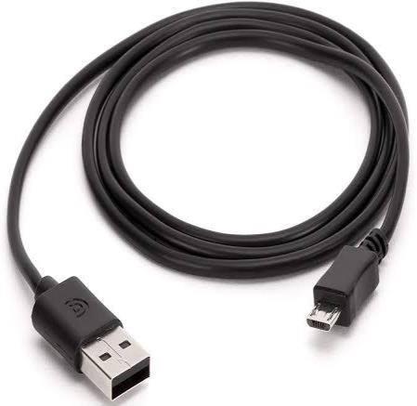

Fig 4.1 USB Cable

Step 2: Download Arduino IDE Software.

You can get different versions of Arduino IDE from the Download page on the Arduino Official website. You must select your software, which is compatible with your operating system (Windows, IOS, or Linux). After your file download is complete, unzip the file.
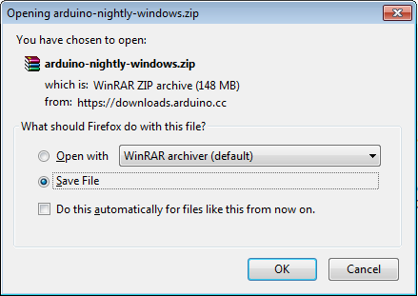

Step 3: Power up your board.

The Arduino Uno, Mega, Duemilanove and Arduino Nano automatically draw power from either, the USB connection to the computer or an external power supply. If you are using an Arduino Diecimila, you have to make sure that the board is configured todrawpowerfromtheUSBconnection.Thepowersourceisselectedwithajumper,a
small piece of plastic that fits onto two of the three pins between the USB and power jacks. Check that it is on the two pins closest to the USB port. Connect the Arduino board to your computer using the USB cable. The green power LED (labeled PWR) should glow.
Step 4: Launch Arduino IDE.
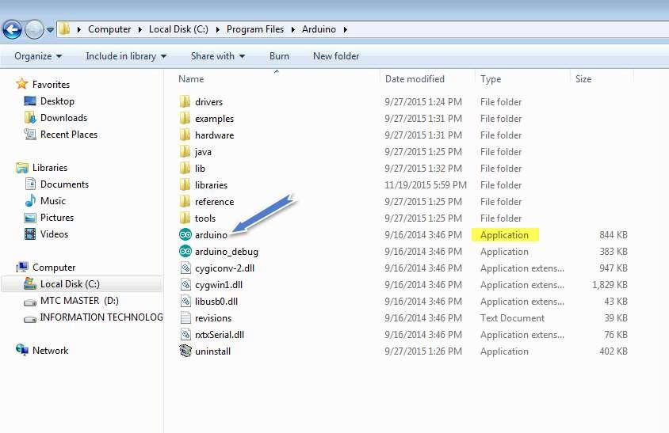
After your Arduino IDE software is downloaded, you need to unzip the folder. Inside the folder, you can find the application icon with an infinity label (application.exe). Doubleclick the icon to start theIDE.

Step 5: Open your first project.
Once the software starts, you have two options: Create a new project.
Open an existing project example.
To create a new project, select File -->New.To open
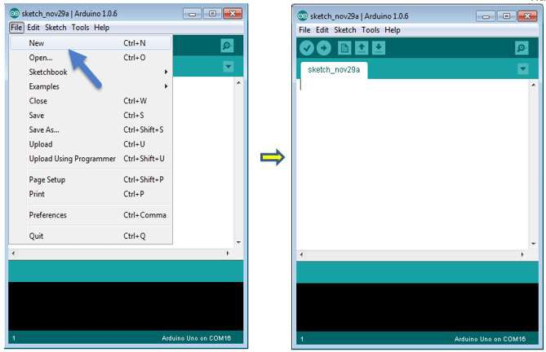

To open an existing project example, select File -> Example -> Basics -> Blink.
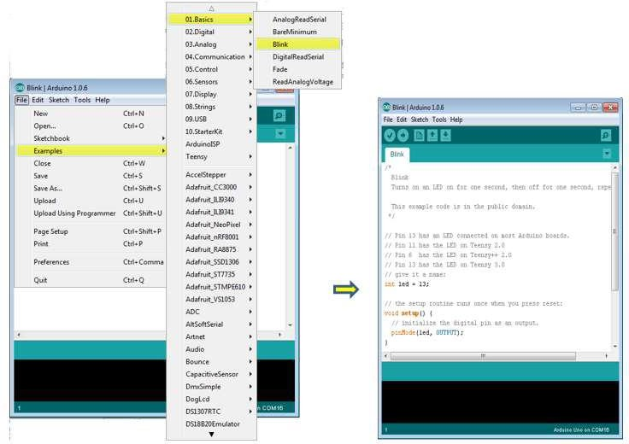

Here, we are selecting just one of the examples with the name Blink. It turns the LED on and off with some time delay. You can select any other example from the list.

Step 6: Select your Arduino board.
To avoid any error while uploading your program to the board, you must select the correct Arduino board name, which matches with the board connected to your computer.
Go to Tools -> Board and select your board

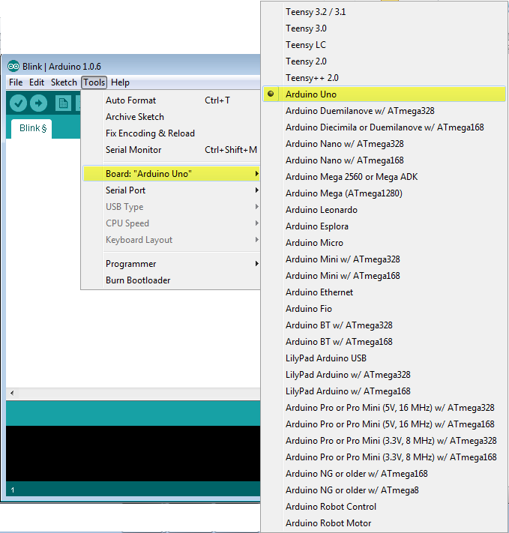

Here, we have selected Arduino Uno board according to our tutorial, but you must select the name matching the board that you are using
Step 7: Select your serial port.
Select the serial device of the Arduino board. Go to Tools ->Serial Port menu. This is likely to be COM3 or higher (COM1 and COM2 are usually reserved for hardware serial ports). To find out, you can disconnect your Arduino board and re-open the menu, the entry that disappears should be of the Arduino board. Reconnect the board and select that serialport.

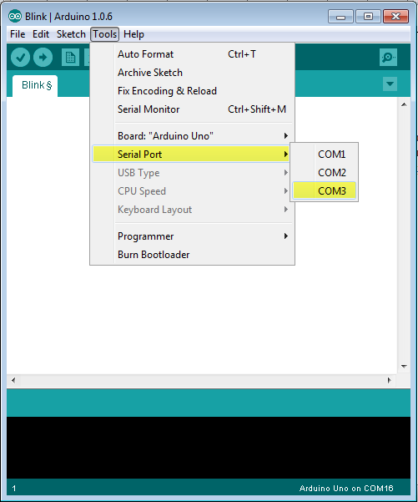

Step 8: Upload the program to your board.
Before explaining how we can upload our program to the board, we mustdemonstrate the function of each symbol appearing in the Arduino IDE toolbar.
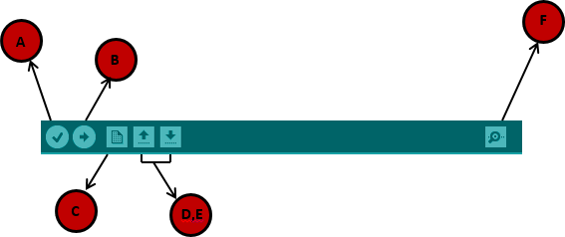

A- Used to check if there is any compilation error. B- Used to upload a program to the Arduino board.
C- Shortcut used to create a new sketch.
D- Used to directly open one of the example sketch. E- Used to save your sketch.
F- Serial monitor used to receive serial data from the board and send the serial data to theboard.
Now, simply click the "Upload" button in the environment. Wait a few seconds; you will see the RX and TX LEDs on the board, flashing. If the upload is successful, the message "Done uploading" will appear in the status bar.
Note: If you have an Arduino Mini, NG, or other board, you need to press the reset button physically on the board, immediately before clicking the upload button on the ArduinoSoftware.

ARDUINO PROGRAMMING STRUCTURE

In this chapter, we will study in depth, the Arduino program structure and we will learn more new terminologies used in the Arduino world. The Arduino software is open- source. The source code for the Java environment is released under the GPL and the C/C++ microcontroller libraries are under the LGPL.

Sketch: The first new terminology is the Arduino program called “sketch”. Structure
Arduino programs can be divided in three main parts: Structure, Values (variables and constants), and Functions. In this tutorial, we will learn about the Arduino software program, step by step, and how we can write the program without any syntax or compilation error.
Let us start with the Structure. Software structure consist of two main functions: Setup( ) function
Loop( ) function

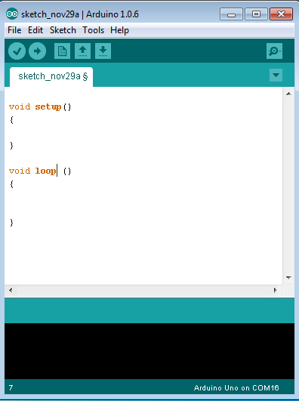

Void setup ( )
{
}

PURPOSE:
The setup() function is called when a sketch starts. Use it to initialize the variables, pin modes, start using libraries, etc. The setup function will only run once, after each power up or reset of the Arduinoboard.
INPUT
OUTPUT
RETURN

Void Loop ( )
{
}

PURPOSE:
After creating a setup() function, which initializes and sets the initial values, the loop() function does precisely what its name suggests, and loops secutively, allowing your program to change and respond. Use it to actively control the Arduinoboard.
INPUT
OUTPUT
RETURN

CHAPTER 5
CONCLUSION
The IoT-based coal mine safety monitoring system offers a practical and affordable solution for enhancing worker safety in hazardous environments. By integrating sensors, microcontrollers, and IoT connectivity, the system ensures early detection of dangerous conditions, real-time alerts, and remote monitoring. Its portability and cost-effectiveness make it suitable for widespread adoption in mining operations. This project demonstrates how IoT can transform traditional industries by improving safety, efficiency, and reliability.

REFERENCES
- P. K. Sahu, A. K. Sahoo — "IoT Based Coal Mine Safety Monitoring System"
- J. Y. Lee, S. H. Kim — "Gas and Temperature Monitoring in Underground Mines Using IoT"
- Sajjad Hussain, Khizer Saeed — "IoT Applications in Industrial Safety: A Review"
- Vinay Meshram, Pranit Bonde — "Smart Mine Safety System Using IoT and Cloud Integration"
- R. C. Luo, M. G. Kay — "Multisensor Integration and Fusion in Intelligent Systems"
- NodeMCU Documentation — "NodeMCU: An Open-Source Lua-Based Firmware for IoT Applications"
- Datasheet — "MQ Series Gas Sensor Technical Reference"
- Datasheet — "ESP8266 Wi-Fi Module Specifications"
- IEEE Xplore — "IoT-Based Smart Safety Devices for Hazardous Environments"
- ResearchGate — "IoT in Mining Safety Systems"
- M. Rashid — "Power Electronics: Circuits, Devices and Applications"

RESULTS

